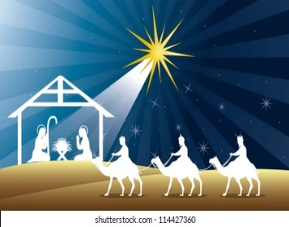***December Good News 2022***



**Our ministry vision for the Virginia Annual Conference is *“to be disciples of Jesus Christ who are lifelong learners, who influence others to serve.”***

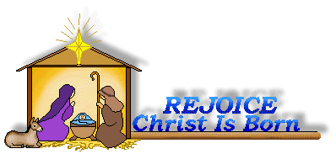

**From Pastor Adam**

**“The Many Dimensions of Our Saving Hope”**

*“And now, you will conceive in your womb and bear a son, and you will name him Jesus.”*  Luke 1:31

*“She will bear a son, and you are to name him Jesus, for he will save his people from their sins.*

Matthew 1:21

“*A baby is God's opinion that the world should go on.” ~*Carl Sandburg

The gospels give us two different (but obviously linked) versions of the Angel Gabriel’s words to the Holy Family as he announces the expected birth of Jesus. Luke’s gospel tells us of Gabriel’s visit to Mary, and Matthew tell us of Gabriel’s visit with Joseph. It seems right and good that God would send the heavenly messenger to both parents: first to include everyone, and secondly, because the birth of a child to a virgin mother is so miraculous and out of the norm that it requires a little explanation from heaven (which God provides through the angel). Even in this early part of Jesus’ story, we begin to get a sense of what his purpose and role is. The name “Jesus” is a Greek version of the Aramaic name *“Yeshua”* which comes from the more ancient Hebrew word pronounced *“yah-sha”* and means “to save” or “to rescue”. Jesus’ name indicates his role: to save or rescue humanity. We might say that this rescuing of the human race happens in two ways. First, Jesus teaching and example gives humanity the model for living peaceably and meaningfully together – the way of life that promotes our collective well-being and curbs our self-destructive ways. We might say that Jesus’ model is one of sane, just, and compassionate living – just the sort of thing that, if put into practice, would prevent our global extinction. Secondly, Jesus’ being the very Son of God and his sacrificial death are both understood as the means by which we are saved from our sins. Some traditions of the church emphasize the fact that as the Son of God, Jesus has the authority to forgives the sins of the human race by means of his divine nature alone. Other traditions emphasize Jesus’s death on the cross as a kind of transaction in which the punishment or harm sin produces falls to Jesus rather than to us, and we escape seemingly unscathed. These two different visions have become intertwined, working together through life of the church to give us a picture of Jesus in which “being” and “sacrifice” both have saving purpose.

It is no mistake that the gospels spends a good bit of time describing the birth and early life (“the nativity”) of Jesus. The gospels devote about two chapters each to the subject. This shows us that Jesus’ birth and early life are as important as his teaching, miracles, and faithfulness unto death. This *feature demonstrates the Bible’s intention to show us that God’s presence and action in* Jesus is meant to include and embrace the whole of the human experience. The Redeemer must touch the whole of life in order to redeem all of life. In order to be our savior and rescuer, the Divine Son must come to us as one of us, and to live a life that is completely and authentically human. God’s complete identification with us in

Jesus must begin with the most basic feature – birth and infancy. Regardless of who we are and what our life’s journey looks like in its unfolding, we are all born and we go from there. From the least to the greatest, we share this common starting point. It matters that God’s Messiah does not come to us as a fully-formed adult or as an obviously otherworldly being, instead God fully embraces and celebrates humanity by sending his Son in the fullness of human fragility and vulnerability – as a baby. To me, this truth adds new dimension to the observation made by Carl Sandburg, that indeed *“A baby is God's opinion that the world should go on.”*

*For unto us a child is born, unto us a son is given...* (Isaiah 9:6)

 ~God’s peace to you and yours, Adam

**Choir News**

We will practice on Tuesday, December 13, 2022, at 6:30 p.m. Come and lend your voice. All are invited!!

~*Heather Wilson*, Director of Music

**Circle News**

* * * * * * * * * * * * * * * * * * *

The **Merry Marthas Circle** will not meet in December, but if anyone wants to go to the Advent Brunch on December 3rd, at Rustburg UMC, please let Judy Robertson or Ann Robbins know.

The **Wesleyan Group** will meet on Monday, December 12, 2022, at Charley’s (Graves Mill Rd.) at 6:30 p.m.

*Mission Memo*

The mission cart contained 133lbs of food for November. Park View Mission was thankful to receive sides to give the clients to make their Thanksgiving meals complete. Thank you to all who faithfully support this mission each month. Your giving spirit is a blessing to our community.

For December the mission is asking for laundry detergent and dishwashing liquid. Also we can continue to collect side dish items for a Christmas meal.

~*Thank you the Mission Committee*

**Food Cart...**

 Items needed for the Food Cart for ***Park View Community Mission.***

For the Month of **December**

Laundry Detergent, Dishwashing Liquid, & side items for a Christmas meal.

*Place donations in the grocery cart, located in the Commons*. **No “*baked goods*” of any kind.** *Place donations in the grocery cart, located in the Commons*

 **Christmas Offering**

We have set a goal of $6,000, with 10% going to Park View Community Mission,

and 90% toward HVAC repair/replacement for social hall and educational building.

***Mark your calendar***…We will have a congregational Christmas luncheon on **Sunday, December 11th**, after church. Chicken and ham will be provided. Please bring **one** covered dish (hot or cold) and/or dessert. Sign-up sheets are being placed in the bulletins for what you are bringing and for what help you can provide. Non-member guests are welcome!

Pat Short's **"Mitten Tree Trunk"** will again be available for donations of mittens, gloves, hats, scarves, and socks. These will be distributed as needed by HumanKind, so they can be purchased after Christmas when on sale if you like.

***Gifts & Memorials***

In Memory of *Bill & Georgia Mason*

Given by: Susan Ferrentino

**Angel Tree**

We now have our Angel Tree for children of Humankind "Ways To Work" clients set up in the Commons. You may shop for your angel and return wrapped gifts to church No LATER than **December 18th**, or you may choose to donate money and the Humankind staff will shop and wrap the gifts. Checks should be made out to ***“Chestnut Hill UMC”*** and marked for **Angel Tree**, and put in the offering plate by **December 11th**.

***Churches for Urban Ministry Fruit Sale***

We would like to thank you for your support again this year. We sold **15** boxes of fruit. This is one of the main fund raisers for Churches for Urban Ministry. Fruit is to be picked up December 6, 7, or 8 at Chestnut Hill UMC.

*Chestnut Hill United Methodist Church extends Christian love and sympathy* to the family of *Henry Short* and especially to his children, Susan, Steve, and Diana. He is Pat Short’s former husband. Mr. Short passed away on November 20, 2022.

And to the family of *John C. Loving* and especially to his son, Rick (wife, Robin). Mr. Loving passed away on November 6, 2022.

***Estimate of Giving for 2023***

It is that time of year when we are all asked to take a prayerful look at our giving and to make a financial commitment for CHUMC ministries. Please fill out the “tear off” pledge below and send to CHUMC or put it in the weekly offering plate during December so that we have your pledge by the end of December. We plan to have a luncheon after church in February to celebrate our statement of faith to support the ministries of CHUMC. More information provided later.

_ _ _ _ _ _ _ _ _ _ _ _ _ _ _ _ _ _ _ _ _ _ _ _ _ _ _ _ _ _ _ _ _ _ _ _ _ _ _ _ _ _ _ _ _ _ _ _ _ _ _ _ _ _ _ _ _ _ _ _ _ _ _ _ _ _ _ _ _

**Estimate of Giving for 2023**

*Chestnut Hill United Methodist Church*

Name(optional)_______________________________________________________________

After prayerful consideration, and with God’s help,

I/we estimate my/our giving to the **General Fund Budget** in 2023 will be $_____________________________________

Circle one: Weekly Monthly Yearly

And I/we estimate my/our giving to the **Joy in Mission Fund** in 2023

will be $________________________________.

Circle one: Weekly Monthly Yearly





1 Yvonne Fisher

3  Hunter Lipscomb

6 Rachel Cole

Andrea Dodgion

Dawn Henson

Jennifer Jessen

7  William Tedder

9 Mark Collins

10  Nathan Gunter

Jeffrey Johnson

11  Rayford Sowell

12 Patricia Copes

13  Heather Stewart

16 Glenn Collins

Christopher Gunter

17 Chris Glass

Megan Gunter

Susan Putnam

18 Linda Stables

28 Glynis Ashby

20 Dana Ayers

Belinda Harris

Travis Maddox

21 Rev. Becky Cloud

Rebecca Steward

22 Neta Pearson

Jane White

23  Linda Jessen

Loretta Mayhew

Michael Redwood

Shaman Sunderland

26  Jane Muller

29 Cookie Fish

30 Christopher Woolley



1 Pat Short

2 Nancy Lee

Emily V.

Fernandez

3 Michael McGlothlin

6 Kirsten Bell

Tim Crist

Dennis Tolley

7 Kenny Busic

Cheryl Powell

9 Owen Stinnette

Jeremey

VandeBogart

11 Landen Glass

12 Camden Mason

14 Wade Ware

16 Burton Brooks

Terry Palazzi

Anne-Elaine Tiller

17 Suzanne

Marshall

Blake Phillips

18 Sharon

Rickmon

19 Connie Yost

20 Erin Ecklund

21 Steven Kinzer

22 C.O. Bell

25 Frankie

Hardwick

28 Jacqueline Busic

Cheryl Thomas

29 Wes Robbins

Ricky Smith

31 Robert Baunach

**2022**

|  |  |
| --- | --- |
| **Those Who Serve~December**  **GREETERS:**  December 4 ~ *Tucker Cole*  December 11 ~ *Jane White*  December 18 ~ *Mary Walker*  December 25 ~ *Betty Taylor*  + + + + + + + + + + + + + + + + + + + + + + +  **GOOD NEWS** is published monthly for members and friends of Chestnut Hill United Methodist Church. Send articles to the church office by the 15th of the month. **(Subject to change.)**  **NOTE**: We will be combining the newsletter for January/February 2023. Deadline for articles will be Monday, December 19, 2022 | **Our Church Financial Picture**  Through the end of October 2022  General Operating Funds:  Needed to meet our 2022 Budget $ 194,759.00  Needed to meet our budget to date $ 162,299.00  Actual receipts to date $ 134,778.00  Shortage to meet budget to date $ 27,521.00  Actual expenditures to date $ 139,564.00  Shortage to meet expenses to date $ - 4,786.00  Joy In Missions Funds:  Our Giving Goal for 2022 $ 11,600.00  Needed to meet our goal to date $ 9,667.00  Actual receipts to date $ 8,200.00  Special Offerings* (not budgeted):  Received to date $ 15,113.00  Dispersed to date $ 12,640.00  *Christmas, Easter, Annual Conference,  World Communion, etc.  **2022 Joy In Mission Donations**  To date, the following amounts have  been paid to the missions indicated.  Budget Spent  1. Missionary Covenant Relationship $1,000 $750  2. Interfaith Outreach $1,000 $750  3. Park View Mission, Food for  Families $3,000 $2,705  4. Society of St. Andrew $1,000 $500  1. Adult Care Center $ 500 $375  2. Blue Ridge Area Food Bank $ 1,000 $750  3. Camp Timothy $ 500 $500  4. Churches for Urban Ministry $ 500 $375  5. Daily Bread $ 500 $375  6. Free Clinic $ 500 $375  7. Good Neighbor $ 500 $0  8. Habitat for Humanity $ 500 $375  9. UMCOR-Non-Administrative $ 500 $0  10. Undesignated $ 600 $0  Thank You for Your Generosity |

**March 2022**



January 2022

**2022**



**2022**

|  |  |  |  |  |  |  |
| --- | --- | --- | --- | --- | --- | --- |
| **Sunday** | **Monday** | **Tuesday** | **Wednesday** | **Thursday** | **Friday** | **Saturday** |
| **From Your Staff**  **Pastor Adam, Erin, Monica,**  **Judy, and Heather**  Merry  Christmas | | | | **1**  **2022** | **2**  **2022**  10:00am Homeschool  6:30pm Homeschool Teen Christmas Party | **3**  **2022**  District UMW Advent Brunch @ Rustburg UMC |
| **4** *2nd Sunday of Advent*  9:30am Sunday School  10:30am Worship | **5**  5:00pm CSE Craft Event (Camp Meadowlark) | **6**  CITRUS Fruit Sale Drop Off | **7**  CITRUS Fruit Sale Drop Off | **8**  CITRUS Fruit Sale Drop Off | **9**  10:00am Homeschool  5:30pm Homeschool Talent Gala | **10** |
| **11** *3rd Sunday of Advent*  9:30am Sunday School  10:30am Worship  11:45am CHUMC Christmas Luncheon | **12**  6:30 pm Wesleyan Group @ Charley’s | **13**  6:30pm Choir  6:30pm Homeschool Game Night | **14** | **15** | **16**  10:00am Homeschool | **17** |
| **18** *4th Sunday of Advent*  9:30am Sunday School  10:30am Worship | **19** | **20**  6:30 pm Homeschool Game Night | **21** | **22** | **23** | **24** *Christmas Eve*  4:30pm Christmas Eve Service |
| **25** *Christmas Day*  9:30am Sunday School  10:30am Worship | **26**  Church Office Closed | **27** | **28** | **29** | **30**  Church Office Closed | **31** |



**April 2022**

**April 2022**

**March 2022**

*Chestnut Hill United*

*Methodist Church*

4660 Fort Avenue, Lynchburg, VA 24502

Phone Number: 434-239-8423: FAX: 434-239-7209

E-mail: [chestnuthillumc@comcast.net](mailto:chestnuthillumc@comcast.net)

On the web: www.chestnuthillumc.net

Church Office Hours

**Monday-Thursday~**9:00 am—3:30 pm

**Friday~**9:00 am-1:00 pm

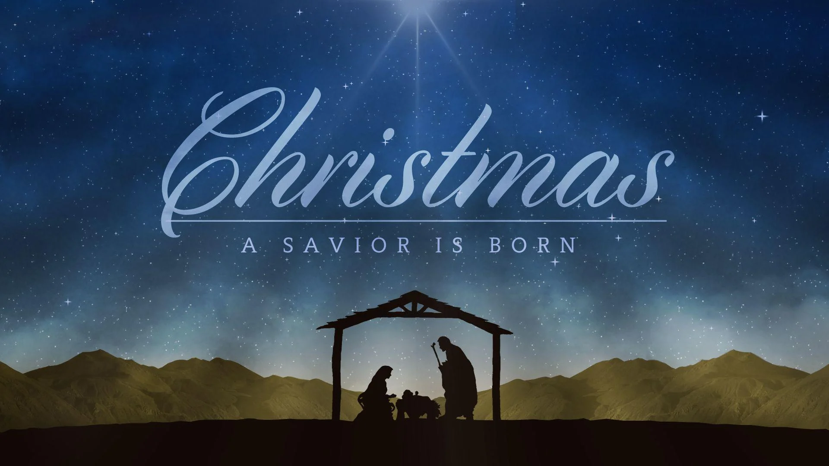

***DIRECTORY OF***

***CHESTNUT HILL UNITED METHODIST CHURCH***

|  |  |  |
| --- | --- | --- |
|  | Sharma Lewis | Richmond Area Resident Bishop |
|  | Denise Bates | Mountain View District Superintendent |
|  | Adam White | Minister |
|  | Erin Long | Associate Minister |
|  | Monica C. Campbell | Administrative Assistant |
|  | Heather Wilson | Director of Music Ministry |
|  | Judy Martin | Bookkeeper |
|  | Judy Robertson | Lay Leader |